TC-AUTH-017
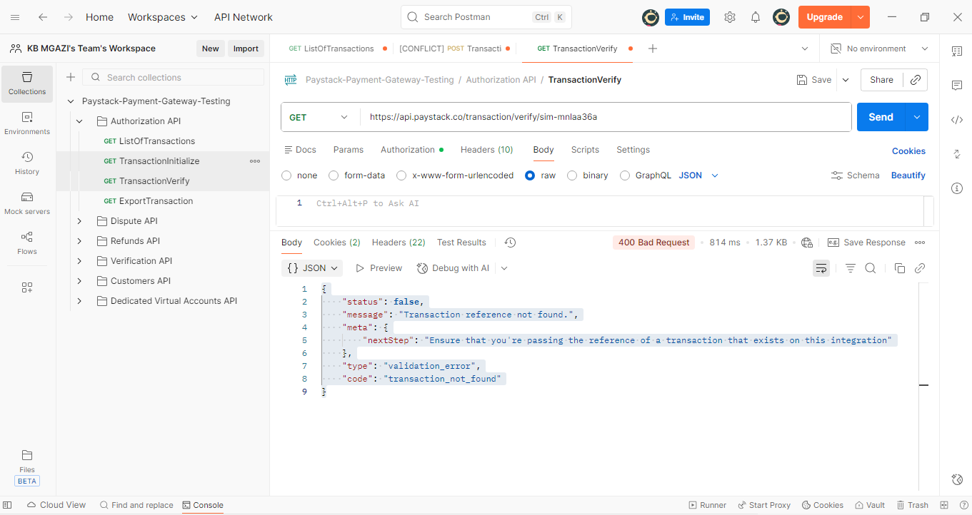
Request:
https://api.paystack.co/transaction/verify/sim-mnlaa36a

Response:
{
"status": false,
"message": "Transaction reference not found.",
"meta": {
"nextStep": "Ensure that you're passing the reference of a transaction that exists on this integration"
},
"type": "validation_error",
"code": "transaction_not_found"
}

